**MongoDB_Assignment-1**

**Exercise-1:** Find all Companies with more than 50 employees.

**Exercise-2**: Find all companies where the tag list includes “wiki”.

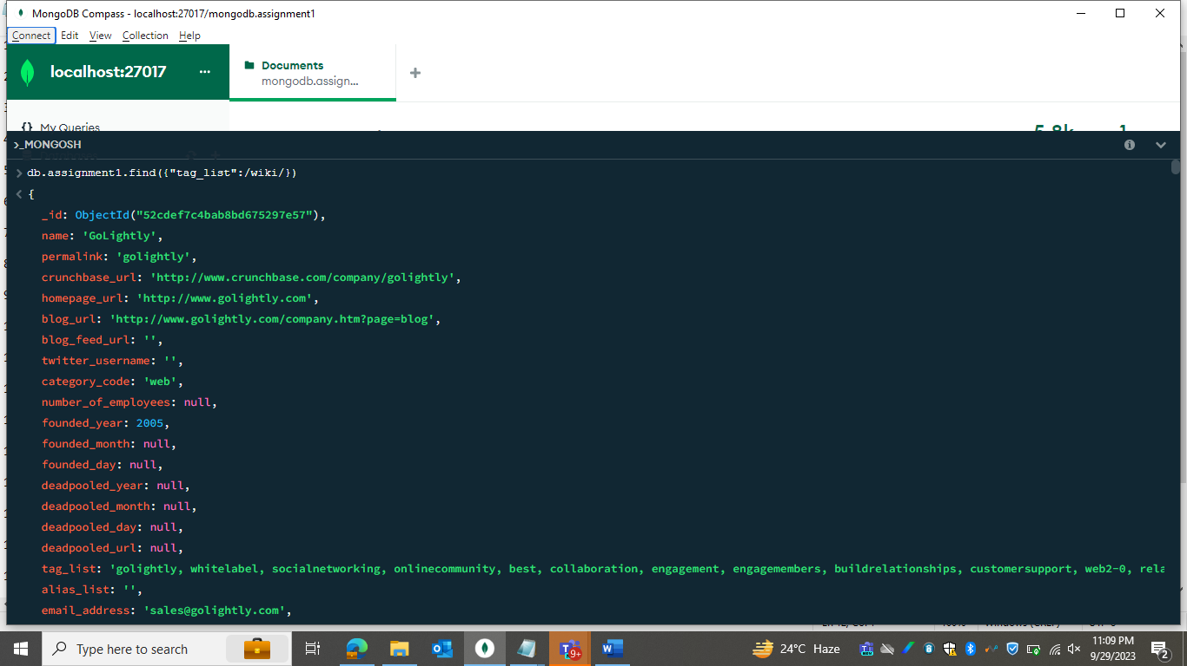

**Exercise-3**: Find all companies with a funding_rounds array size greater than or equal to 3.

**Exercise-4**: Find all companies with a total_money_raised greater than or equal to “$30M”.

**Exercise-5:** Find all companies with the ”web” category code and fewer than 50 employees.

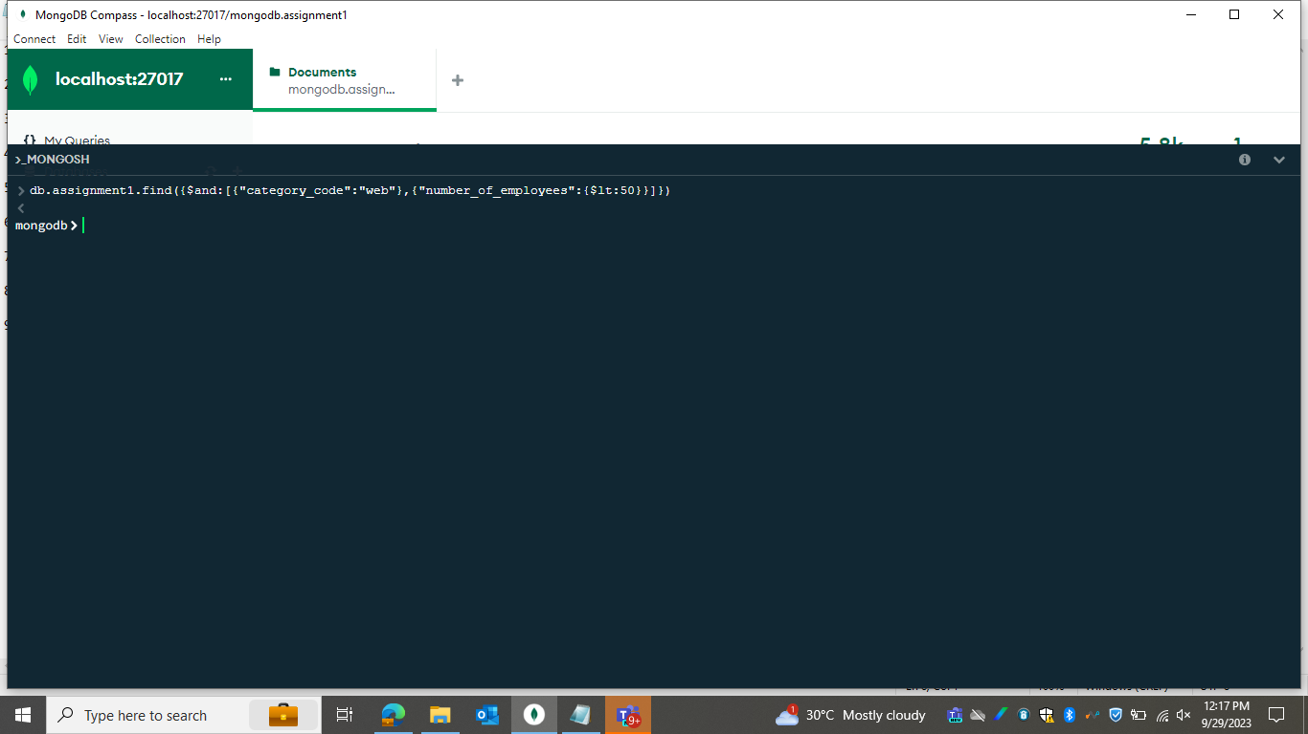

**Exercise-6:** Find all companies with a deadpooled_year of 1 or where deadpooled_year field is missing.

**Exercise-7:** Sort companies by the number of employees in descending order.

**Exercise-8:** Count the number of companies with a twitter_username

**Exercise-9**: Insert a company document with nested address and contacts

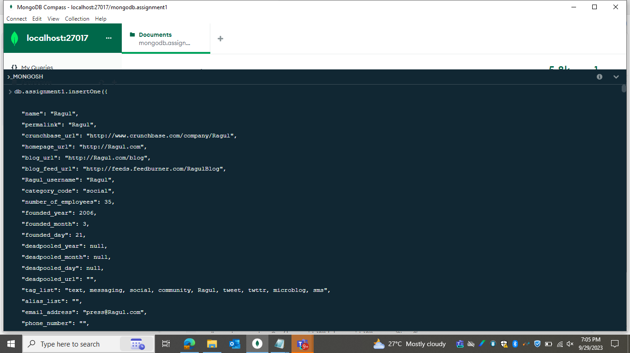

**Exercise-10:** Add a new contact to a specific company document

**Exercise-11:** Update multiple companies categories to” Software”.

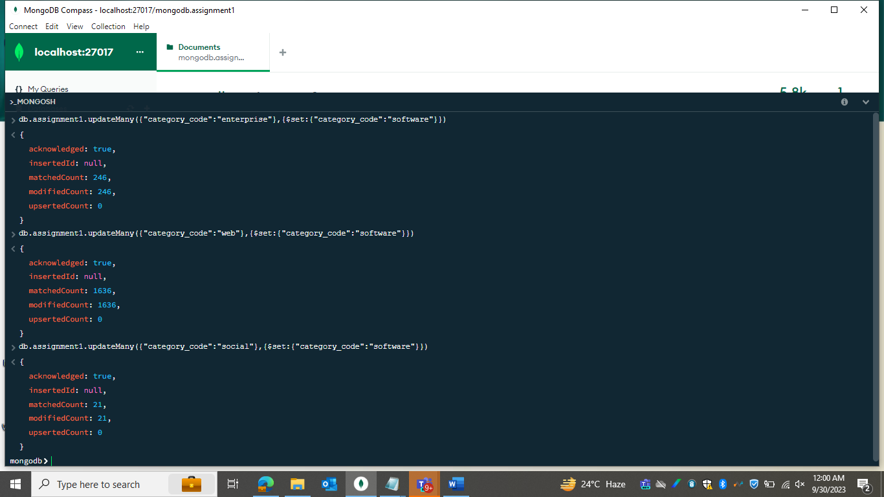

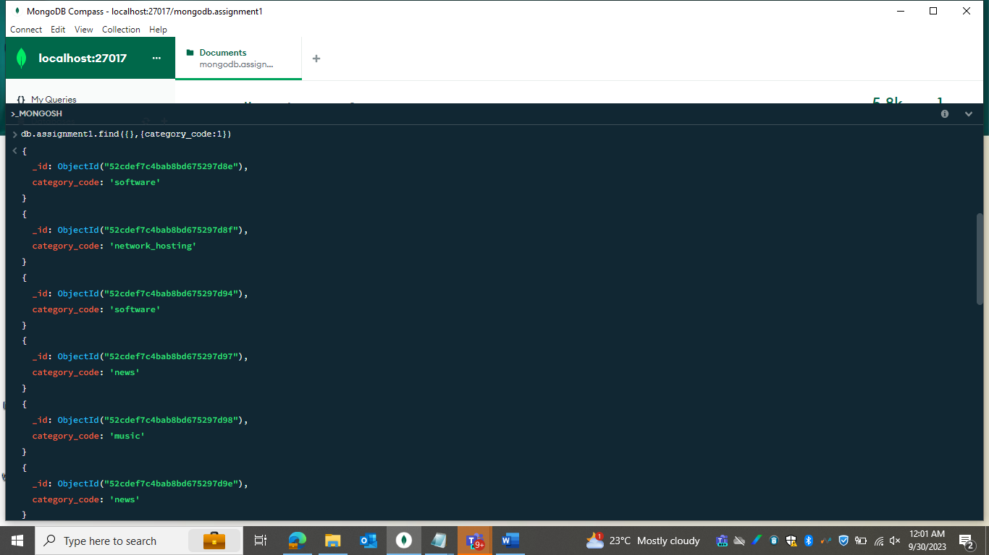

**Exercise-12**: Remove a contact from specific company document by their name.

**Exercise-13:** Increment the number_of_employees by 10 for a specific company with _id.

**Exercise-14**: Find companies with specific contact information (using the $elemMatch operator)

**Exercise-15**: Delete all documents that matches a specific condition (number_of_employees is less than 50).

**Exercise-16**: Delete documents older than a certain date (created at date earlier than January 1, 2022).

**Exercise-17:** Delete documents based on multiple conditions (category_code equals to “web” and the number_of_employees less than 100).

**Exercise-18:** Delete documents based on multiple conditions (category_code equals to “web” and the number_of_employees is 47).

**Exercise-19:** Delete documents where the “tag_list”contains ” Media-platform”.

**Exercise-20:** Delete all document in the Collection.

